INTRODUCTION:
Response spectrum is one of the useful tools of earthquake engineering for analyzing the performance of structures especially in earthquakes, since many systems behave as single degree of freedom systems. Thus, if you can find out the natural frequency of the structure, then the peak response of the building can be estimated by reading the value from the ground response spectrum for the appropriate frequency. In most building codes in seismic regions, this value forms the basis for calculating the forces that a structure must be designed to resist (seismic analysis). A response spectrum is a plot of the maximum response amplitude (displacement, velocity or acceleration) versus time period of many linear single degree of freedom oscillators to a give component of ground motion. The resulting plot can be used to select the response of any linear SDOF oscillator, given its natural frequency of oscillation. One such use is in assessing the peak response of buildings to earthquakes.
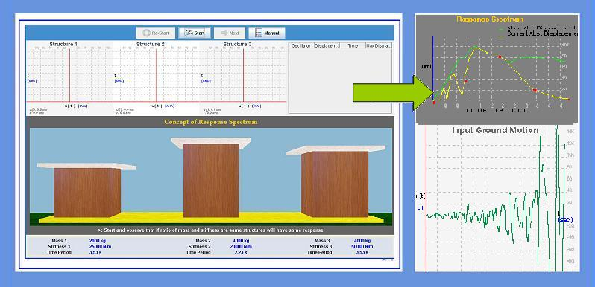
THEORY:

A plot of the peak value of a response quantity as a function of the natural vibration period of the system, or a related parameter such as circular frequency or cyclic frequency is called the response spectrum for that quantity. A variety of response spectra can be defined depending on the response quantity that is plotted. Consider the following peak responses:

The deformation response spectrum is a plot of against for fixed. A similar plot for relative velocity response spectrum and for is the acceleration response spectrum.
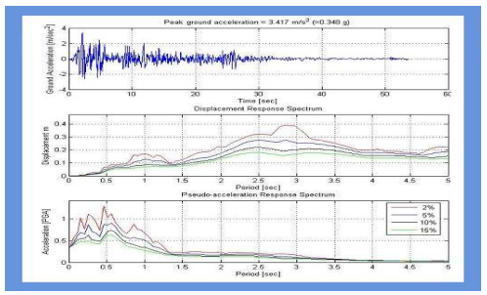

OBJECTIVE:

To understand the concept of response spectrum and to construct the same for a given component of ground motion
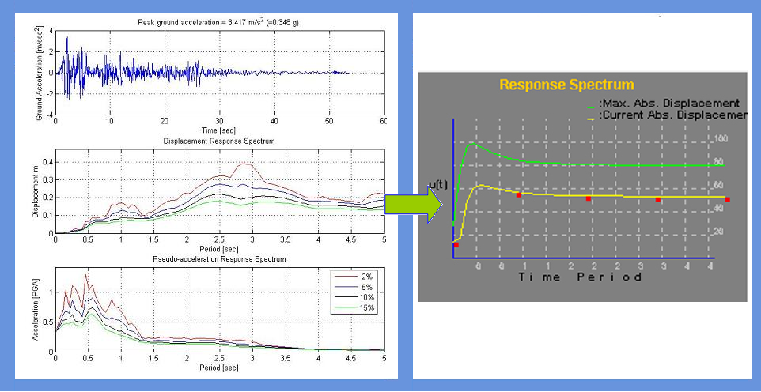
MANUAL:
Observation 1: Concept of response spectrum
There are 3 buildings shown on the screen. User can select mass and stiffness of all 3 buildings. However, user need to make sure that at least two buildings time period is same. Select the earthquake ground motion record and also damping.
Run the experiment.
You will observe after completing that the maximum displacement of the oscillators with same time period is same irrespective of their different masses and stiffnesses.
Observation 2: Construction of response spectrum
1. On the screen you can see 5 different buildings. User can set the time period of each building according to their choice. The range of time periods that can be used from 0.1sec up to 4.0 secs.
2. After selecting time periods, user can select the earthquake ground motion record of their choice. User can also change
3. Start the experiment and observe on right hand side top. User can find the instantaneous response of all 40 buildings (time period 0.1 to 0.4 sec) and also the envelope of maximum response.
4. User may repeat the experiment using different ground motion records and damping values.

PART - 2
ANIMATION STEPS

PART – 3
VIRTUAL LAB FRAME
